

**A Project Topic**

**On**

**“House Hold Smart Share”**

**Submitted by:**

**MD Imran Hosen (18CSE019)**

**Date: July,2023**

**Department of Computer Science & Engineering**

**Bangabandhu Sheikh Mujibur Rahman Science and Technology University**

**House Hold Smart Share**

(This project is submitted in the partial fulfillment of the requirement for the project of " Third Year Second Semester " in Computer Science & Engineering)

By

**MD. Imran Hosen**

**ID: 18CSE019**

Supervised by:

**Md. Monowar Hossain**

Assistant Professor

Department of Computer Science & Engineering

Bangabandhu Sheikh Mujibur Rahman Science and Technology University

**Certificate of Approval**

It is hereby declared that the contents of this project original and any part it has not been submitted else where for the award of any degree.

---------------------------------- ---------------------------------

Signature of the Candidate Signature of the Supervisor

Date: Date:

**Acknowledgement**

The success and final outcome of this project required a lot of guidance and assistance from many people and I am extremely privileged to have got this all along the completion of my project. All that I have done is only due to such supervision and assistance and I would not forget to thank them. I owe my deep gratitude to our project supervisor **Md. Monowar Hossain**, who took keen interest on our project work and guided us all along, till the completion of our project work by providing all the necessary information for developing a good system. I am thankful to and fortunate enough to get constant encouragement, support and guidance from all Teaching staffs of Computer Science and Engineering which helped me in successfully completing my project work.

**Md. Imran Hosen**

July, 2023

**Abstract**

The **House Hold Smart Share** website in Mern stack is an interesting website designed in the object-oriented programming language – javascript, with the use of Visual Studio Code Website. The website is an excellent example of utilization of javascript and html, css programming language in the field of website development. It demonstrates all the basic commands, syntaxes, functions, structures as well as concepts of file handling in Javascript, html and css. In this web website we can upload our old items in this website and those who need these items can request through this website. The main reason for making this web website is that our old things do not turn into dirt and are useful for someone else to use. So that people benefit.

**Table of Contents**

Chapter 1 1

Introduction 1

**1.1 Introduction** 1

**1.2 Motivation** 1

**1.3 Features** 1

**1.4 Objectives** 1

**1.5 Report Organization** 2

Chapter 2 3

Requirement Analysis 3

**2.1 Functional Requirements** 3

**2.2 System Requirements** 3

Chapter 3 4

System Design 4

**3.1 Design Approach** 4

**3.2 Detailed Design** 4

**3.2.1 User Registration:** 4

**3.2.2 Search item:** 4

**3.2.3 Filter Location:** 5

**3.2.4 Checkout and Order:** 5

**3.2.5 Invoice Generation and Uploading:** 5

**3.3 Website Design:** 5

**3.4 ER Diagram:** 5

**3.5 User Interface Design** 6

**3.5 Methodology** 6

Chapter 4 7

Implementation 7

**4.1 Front-end:** 7

**4.1.1 Javascript:** 7

**4.1.2 HTML** 7

**4.1.3 CSS** 8

**4.1.4 Bootstrap** 8

**4.2 Back-end** 8

**4.2.1 Node.js** 8

**4.2.2 ExpressJS** 9

**4.2.3 MongoDB Datebase** 9

**4.3 Code editor:** 10

**4.4 Git version control** 10

Chapter 5 11

Results and Discussions 11

**5.1 Description of Features and the Approach:** 11

**5.1.1 User Login/Registration:** 11

**5.1.2 User Forget Password** 12

**5.1.2 Home page:** 12

**5.1.3 Category View:** 13

**5.1.4 Profile View:** 13

**5.1.5 Create Category** 14

**5.1.6 Upload Product:** 14

**5.1.7 My upload:** 15

**5.1.8 My order:** 15

**5.1.9 Cart Item:** 16

**5.1.10 Filter Item:** 16

**5.1.10 Item details view:** 17

Chapter 6 18

Future Scopes 18

Chapter 7 19

Conclusions 19

References 20

**Table of Figure:**

[Figure 1 ER Diagram 5](https://d.docs.live.net/f356d6c6341b1730/Desktop/Exam/House%20Hold%20Smart%20Share(3.2)(18CSE019)(Report).docx#_Toc141095787)

[Figure 2 Database 9](https://d.docs.live.net/f356d6c6341b1730/Desktop/Exam/House%20Hold%20Smart%20Share(3.2)(18CSE019)(Report).docx#_Toc141095788)

[Figure 3 Git version control 10](https://d.docs.live.net/f356d6c6341b1730/Desktop/Exam/House%20Hold%20Smart%20Share(3.2)(18CSE019)(Report).docx#_Toc141095789)

[Figure 4 Registration Page 11](https://d.docs.live.net/f356d6c6341b1730/Desktop/Exam/House%20Hold%20Smart%20Share(3.2)(18CSE019)(Report).docx#_Toc141095790)

[Figure 5 Login 11](https://d.docs.live.net/f356d6c6341b1730/Desktop/Exam/House%20Hold%20Smart%20Share(3.2)(18CSE019)(Report).docx#_Toc141095791)

[Figure 6 Reset Password 12](https://d.docs.live.net/f356d6c6341b1730/Desktop/Exam/House%20Hold%20Smart%20Share(3.2)(18CSE019)(Report).docx#_Toc141095792)

[Figure 7 Main Page 12](https://d.docs.live.net/f356d6c6341b1730/Desktop/Exam/House%20Hold%20Smart%20Share(3.2)(18CSE019)(Report).docx#_Toc141095793)

[Figure 8 Category View 13](https://d.docs.live.net/f356d6c6341b1730/Desktop/Exam/House%20Hold%20Smart%20Share(3.2)(18CSE019)(Report).docx#_Toc141095794)

[Figure 9 Profile View 13](https://d.docs.live.net/f356d6c6341b1730/Desktop/Exam/House%20Hold%20Smart%20Share(3.2)(18CSE019)(Report).docx#_Toc141095795)

[Figure 10 Search by Location View 14](https://d.docs.live.net/f356d6c6341b1730/Desktop/Exam/House%20Hold%20Smart%20Share(3.2)(18CSE019)(Report).docx#_Toc141095796)

[Figure 11 Upload Product View 14](https://d.docs.live.net/f356d6c6341b1730/Desktop/Exam/House%20Hold%20Smart%20Share(3.2)(18CSE019)(Report).docx#_Toc141095797)

[Figure 12 Own Upload Product View 15](https://d.docs.live.net/f356d6c6341b1730/Desktop/Exam/House%20Hold%20Smart%20Share(3.2)(18CSE019)(Report).docx#_Toc141095798)

[Figure 13 My Order Request View 15](https://d.docs.live.net/f356d6c6341b1730/Desktop/Exam/House%20Hold%20Smart%20Share(3.2)(18CSE019)(Report).docx#_Toc141095799)

[Figure 14 Update Profile View 16](https://d.docs.live.net/f356d6c6341b1730/Desktop/Exam/House%20Hold%20Smart%20Share(3.2)(18CSE019)(Report).docx#_Toc141095800)

[Figure 15 Filter Item 16](https://d.docs.live.net/f356d6c6341b1730/Desktop/Exam/House%20Hold%20Smart%20Share(3.2)(18CSE019)(Report).docx#_Toc141095801)

[Figure 16 Item details view 17](https://d.docs.live.net/f356d6c6341b1730/Desktop/Exam/House%20Hold%20Smart%20Share(3.2)(18CSE019)(Report).docx#_Toc141095802)

# **Chapter 1**

# **Introduction**

Now we are living in the ocean of science and technology. This is possible for the purposes of programing. The main purpose of this project is to introduce programing everyone and practice them. In this, project design and implement a **House Hold Smart Share** app in web website using javascript ,html ,css language. In this app, the user can control this website easily and the user interface of the website is easy to use.

## **1.1 Introduction**

We made this website where we can upload our old items in this website and those who need these items can request through this website. The main reason for making this website is that our old things do not turn into dirt and are useful for someone else to use. So that people benefit.

## **1.2 Motivation**

We have so many things around us that we don't use them. I am motivated to see, how these items can be used. And that could be useful for some people.

## **1.3 Features**

Below describe about some features of our project.

* Easy interface
* Website can be use in android phone
* Upload any type of product
* Search product by your region

## **1.4 Objectives**

We made this website or project so that we could give our best in possible ways and show what we learned. The objectives of this project are:

* To use website in mobile and desktop web browser.
* To make it user friendly.
* To provide an easy interface.
* To help people in their leisure time.

## **1.5 Report Organization**

For run this website we need some requirement which describe in the **Chapter-2: Requirements Analysis.** In the C**hapter-3: System Design s**how the design of this project and |**Chapter-4: Implementation** describe about the implementation of this project. After the implementation we get results which shown and describe in **Chapter-5: Results and Discussions**. We want to update our project in future which discuss In **Chapter-6: Future Scopes.** Finallyin **Chapter-7: Conclusions** we have added short discuss about our project.

# **Chapter 2**

# **Requirement Analysis**

In this chapter describe about the fundamental requirement for run this website also run website. For run this website need an smart device such as android phone or desktop also need internet connection. More details below describe.

## **2.1 Functional Requirements**

Functional requirements are properties that must exist in the final system. For any mobile website, we need to download web website like google chrome from the play store and run this website in this browser. The website is free upon the store or merchant. To use the website, the user needs to register and login to the website after installing by providing login information. Once, user logins into the website, user can use all the features.

## **2.2 System Requirements**

The web website like chrome should be installed into a device for run website and, system or any machine in such a way that it should have basic requirements like supporting software and hardware of the device, accessing in-built software, say camera for mobile device, internet permissions, and potential security issues such as virus or any malware detection.

# **Chapter 3**

# **System Design**

In this chapter explain about the system design of our project. How look our project every activity. We try our best for make design best. All the modules are designed, implemented and integrated together to make a flawless working website.

## **3.1 Design Approach**

This project is based on the functional design approach, which helps in understanding the design of the project in a simpler way by explaining its flow, use cases, and implementation more like a modular approach. For example, there are different modules in this project which have separate functionality and, other sub functionalities/modules. All the modules are designed, implemented and integrated together to make a flawless working website.

## **3.2 Detailed Design**

The detailed design including modules and sub modules of the website is as follows:

### **3.2.1 User Registration:**

If the user wants to use the House Hold Smart Share, they must enter the website from the web website such as chrome and register it by providing login information. Once, they register the registered information is stored on the server and can be validated, checking the valid credentials for the next time he logins with the website, also if user don’t want to registration an account, then the website could be usable by guest mode.

### **3.2.2 Search item:**

The search helps in finding whether the item is available in the store or not. This could help the users save time by searching for the item which is out of stock.

### **3.2.3 Filter Location:**

This feature helps people by allowing them to search location that is available on the item. Once the users search the location, they can see all the information about the item name. Users can scan any number of items they wish and keep adding to their physical add to cart. Later, they can request any item they want by checking the items in the cart.

### **3.2.4 Checkout and Order:**

Checkout is made in an easy step to avoid hassle in this website. The user can just check in with the checkbox from the Order. If the user wishes to request, they can proceed by clicking the “Request” button or they can cancel the purchase at this stage and proceed and with shopping for other items or they can exit the website.

### **3.2.5 Invoice Generation and Uploading:**

Once, the user confirms the purchase, the invoice is generated at the same time and we can share it instantly to cloud (share to drive, send email)

## **3.3 Website Design:**

The main aim of the system design is to explain the scenario using use case diagrams. Use case diagrams clarify the flow of the website by deriving the use cases for all the functionalities in form of diagrams for the users.

## **3.4 ER Diagram:**

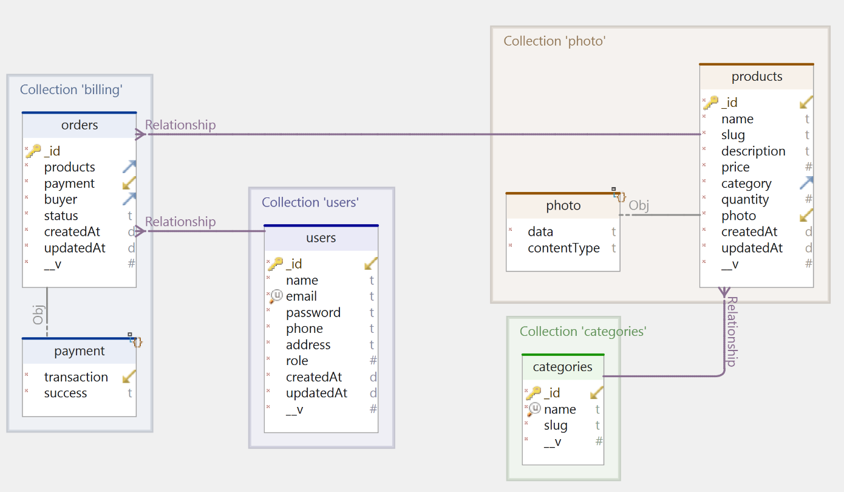

Figure 1 ER Diagram

## **3.5 User Interface Design**

User Interface Design for any website should be very simple. We should have only a few clicks or navigation among the features when using the website to avoid hassle. In this website, there are two main screens, the Login and Home screens. The login page is the first page which appears when the user use the website. In that page, if he is a new user, he can sign up or if he is an existing user, he can login with the credentials. He next screen is the homepage where the users can select features and use the app. The following image is the home screen. As seen from the image, this screen has all the key features.

## **3.5 Methodology**

Agile Software Development Methodology is widely used in many projects as it has many advantages. After gathering the project requirements, it is reviewed frequently in the form of small iterations and made into action by executing it. After completing tasks each iteration, it could be reviewed properly and moved to next iteration [4]. The main advantage of this methodology is that we can change the requirements or design even in the middle of the project when the situation arises. Also, code maintenance is easier in contrast to Waterfall Approach. In Waterfall methodology, there is no flexibility in changing the requirements when we develop the project because we must understand the working flow of the project at least 80% even before the start of the project and work according to that. Only if the design process is done, we can move to construction, testing, and support. Though this is not a team project, we have approached this project using agile methodology by applying its principles. To illustrate, for example: In one of the modules, “Scan an Item”, before start developing it, we have analyzed the design requirements initially and planned to execute them in the form of short iterations which are called “Sprints”. We tried to execute the planned tasks of the iterations accordingly, but We could not able to finish some of the tasks on that particular iteration and they are carried to next sprint and are called “Product Backlogs”. Also, as mentioned, we have changed some of the requirements for the convenience of the user interface while developing the project which is the main advantage of this methodology. Hence, for these reasons, we had decided to follow the principles of agile methodology.

# **Chapter 4**

# **Implementation**

In this chapter discuss about the implementation of our project. What programming language and website we use for build this website.

## **4.1 Front-end:**

HTML, CSS, Bootstrap and JavaScript are the basic languages you need to know to create front-end of a website.

### **4.1.1 Javascript:**

javaScript is a scripting or programming language that allows you to implement complex features on web pages. JavaScript is considered lightweight due to the fact that it has low CPU usage, is easy to implement, and has a minimalist syntax. Minimalist syntax as in, has no data types. Everything is treated here as an object. It is very easy to learn because of its syntax similar to C++ and Java. A lightweight language does not consume much of your CPU’s resources. It doesn’t put excess strain on your CPU or RAM. JavaScript runs in the browser even though it has complex paradigms and logic which means it uses fewer resources than other languages. For example, NodeJs, a variation of JavaScript not only performs faster computations but also uses fewer resources than its counterparts such as Dart or Java. Additionally, when compared with other programming languages.

### **4.1.2 HTML**

HTML stands for HyperText Markup Language. It is used to design web pages using a markup language. HTML is a combination of Hypertext and Markup language. Hypertext defines the link between web pages. A markup language is used to define the text document within the tag which defines the structure of web pages. This language is used to annotate (make notes for the computer) text so that a machine can understand it and manipulate text accordingly. Most markup languages (e.g. HTML) are human-readable. The language uses tags to define what manipulation has to be done on the text

### **4.1.3 CSS**

CSS (Cascading Style Sheets) is used to styles web pages. Cascading Style Sheets are fondly referred to as CSS. The reason for using this is to simplify the process of making web pages presentable. It allows you to apply styles on web pages. More importantly, it enables you to do this independently of the HTML that makes up each web page.

### **4.1.4 Bootstrap**

Bootstrap is a free, open source front-end development framework for the creation of websites and web apps. Designed to enable responsive development of mobile-first websites, Bootstrap provides a collection of syntax for template designs.

## **4.2 Back-end**

Back-end development means working on server-side software, which focuses on everything you can’t see on a website. Back-end developers ensure the website performs correctly, focusing on databases, back-end logic, website programming interface (APIs), architecture, and servers. They use code that helps browsers communicate with databases, store, understand, and delete data. In the back-end we use NodeJS, ExpressJS, MongoDB.

### **4.2.1 Node.js**

A framework is a collection of various libraries and tools that are required in the development process of a software website. It acts as a base on which different software websites can be developed. A node framework is a workspace platform that supports the use of Node.js and which allows developers to use JavaScript for developing front end as well as the back end of an website. Node frameworks are a wide collection of frameworks built on Node and that extend its properties and functionalities further.

### **4.2.2 ExpressJS**

Express is a node js web website framework that provides broad features for building web and mobile websites. It is used to build a single page, multipage, and hybrid web website

### **4.2.3 MongoDB Datebase**

MongoDB is a document-oriented NoSQL database used for high volume data storage. Instead of using tables and rows as in the traditional relational databases, MongoDB makes use of collections and documents. Documents consist of key-value pairs which are the basic unit of data in MongoDB. Collections contain sets of documents and function which is the equivalent of relational database tables. MongoDB is a database which came into light around the mid-2000s. Below the screenshot of database.

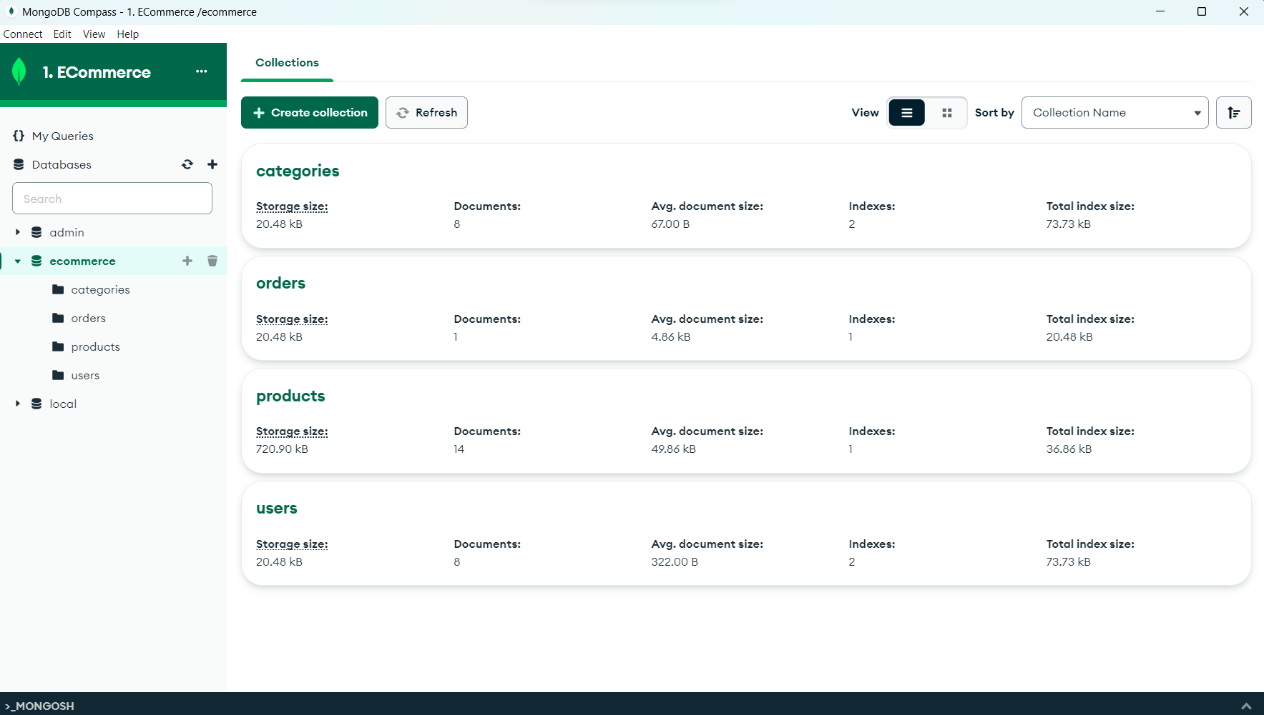

Figure 2 Database

## **4.3 Code editor:**

We use vs-code for primary code editor. Visual Studio Code is a source-code editor made by Microsoft with the Electron Framework, for Windows, Linux and macOS. Features include support for debugging, syntax highlighting, intelligent code completion, snippets, code refactoring, and embedded Git.

## **4.4 Git version control**

Git is a version control system that developers use all over the world. It helps you track different versions of your code and collaborate with other developers. If you are working on a project over time, you may want to keep track of which changes were made, by whom, and when those changes were made. This becomes increasingly important if you end up having a bug in your code! Git can help you with this.

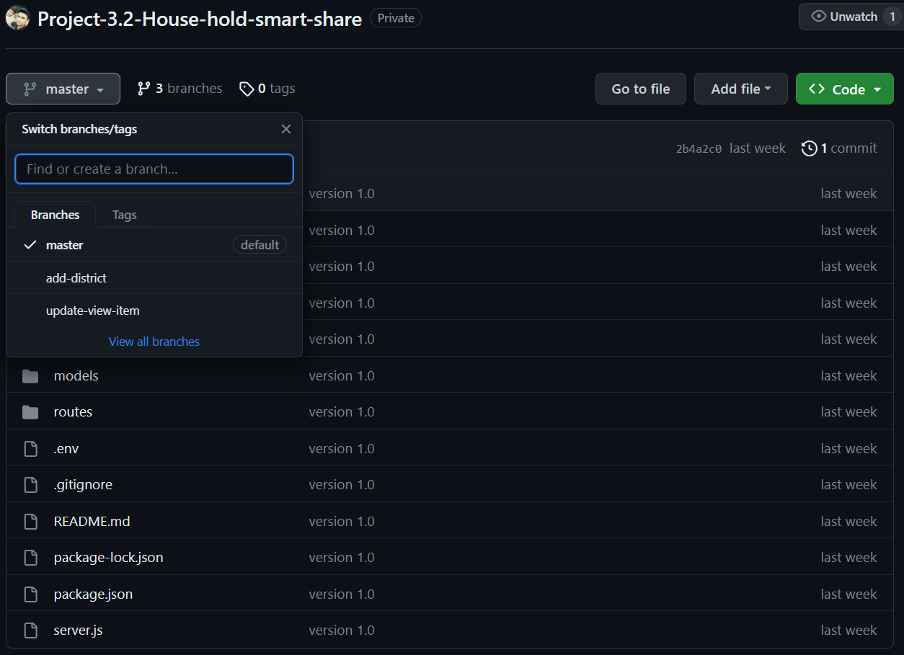

Figure 3 Git version control

# **Chapter 5**

# **Results and Discussions**

In this chapter discuss about the result of our project, the results and discussion may involve an evaluation of the design or method used. In a feasibility or case study, the results and discussion section would involve measuring the feasibility or evaluating the success of one or more solutions.

## **5.1 Description of Features and the Approach:**

Below discuss about the features of this website. Also add some snapshot for better understanding features of this websites

### **5.1.1 User Login/Registration:**

If the user wants to use the House Hold Smart Share, we must visit wepsite from web browser and register it by providing login information. As shown in the Figure-5.1, the login information includes user name and password show in Figure-5.2. For the new user, the user must sign up by providing Full Name, Email Id and Password show in Figure-5.3. Once, he registers, the registered information is stored in the server and can be validated, checking for the valid credentials for the next time he logins with the website.

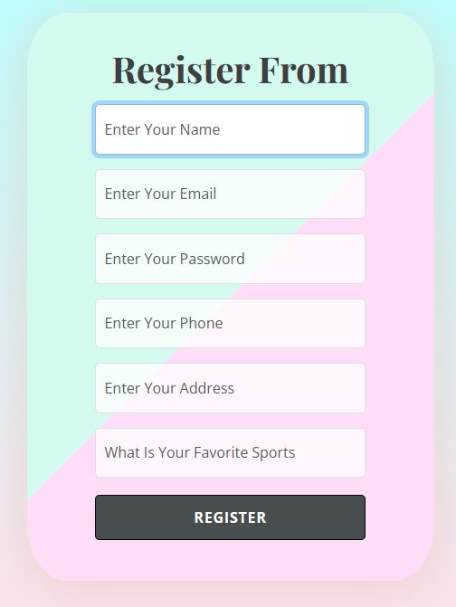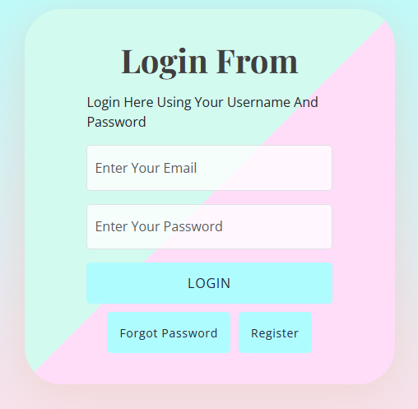

Figure 4 Registration Page

Figure 5 Login

### **5.1.2 User Forget Password**

If a user forget password then user can recover the account using reset password. Where user need email, and favorite Sport which given by the user when account is created. We know it’s less secure but in future we will try better functionality’s.

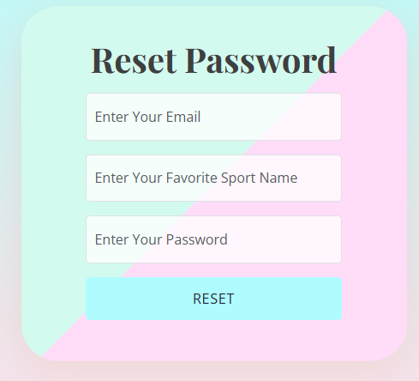

Figure 6 Reset Password

### **5.1.2 Home page:**

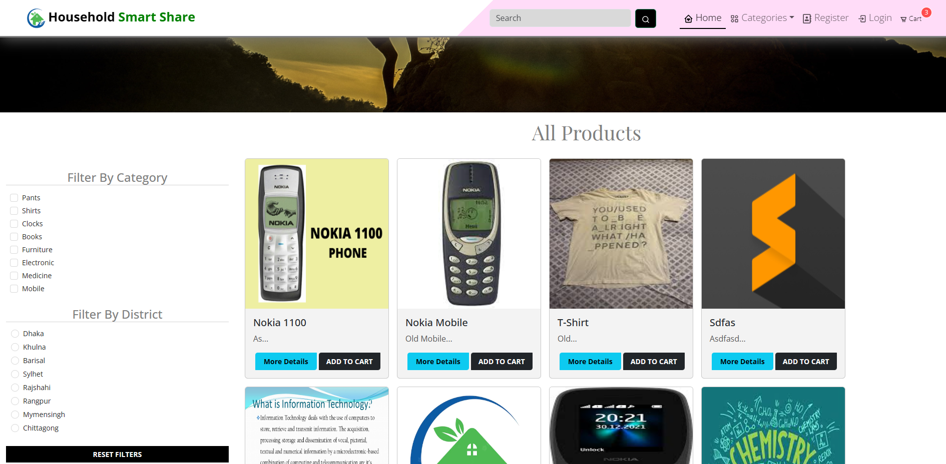Below in Figure-5.4 show the image of home page. In home page upper has a search option where we can search product, also have Popular item Card view, All Type Also food type Card view.

Figure 7 Main Page

### **5.1.3 Category View:**

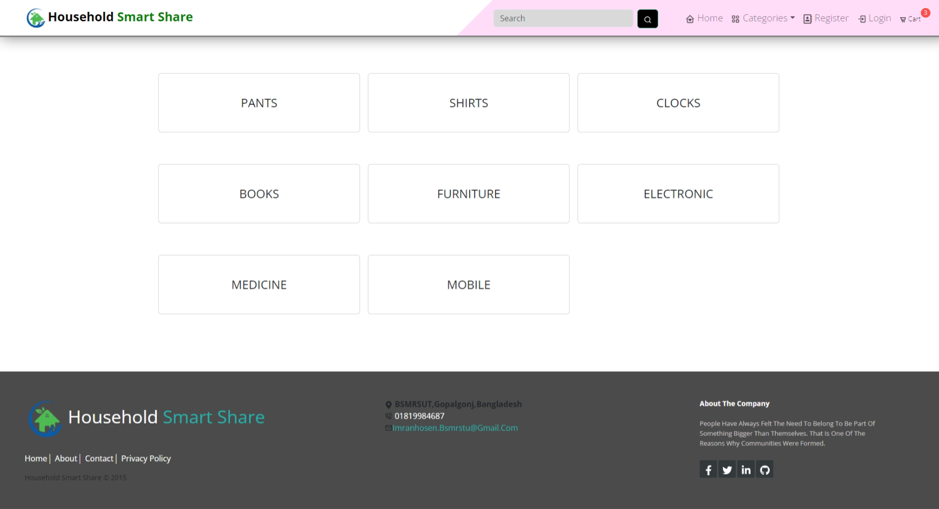This wepsite also has category view. Below the image of category view in Figure-5.6.

Figure 8 Category View

### **5.1.4 Profile View:**

In the profile view we will show our profile details. Below the profile view in Figure-5.7.

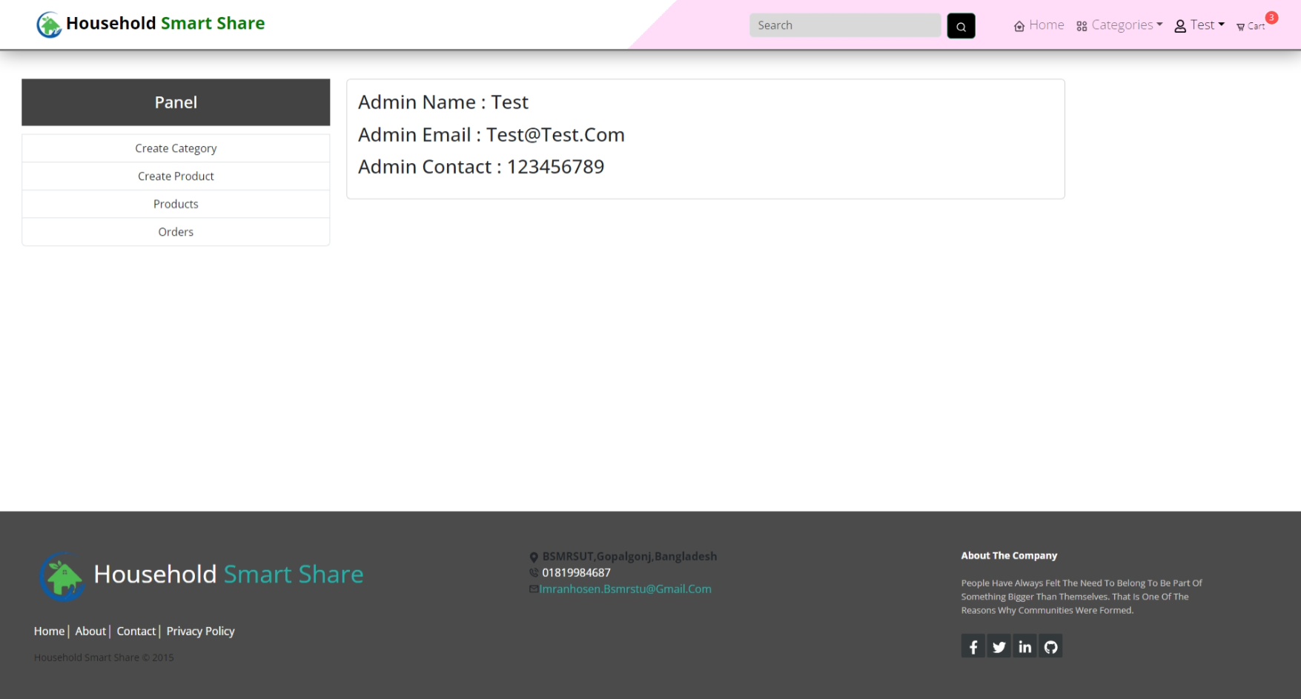

Figure 9 Profile View

### **5.1.5 Create Category**

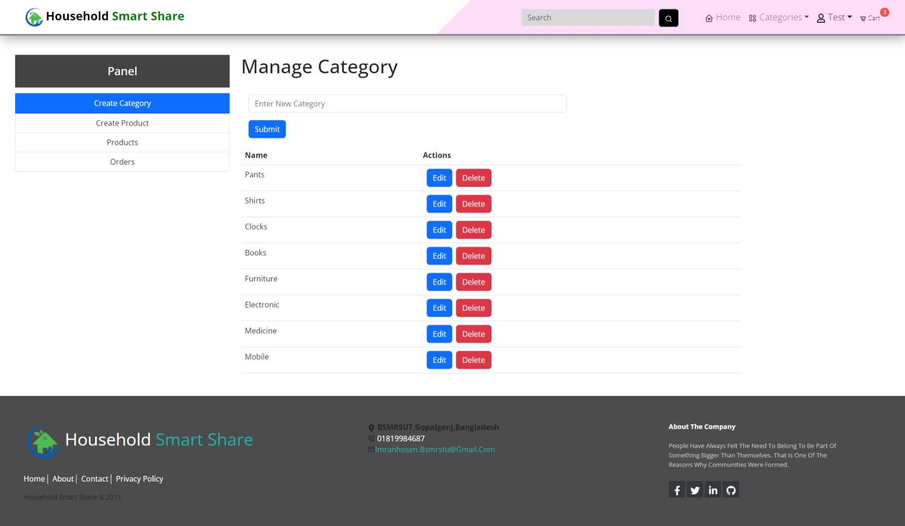Using search by location all products sort by input location. Below the image of Search by location Figure-5.8.

Figure 10 Search by Location View

### **5.1.6 Upload Product:**

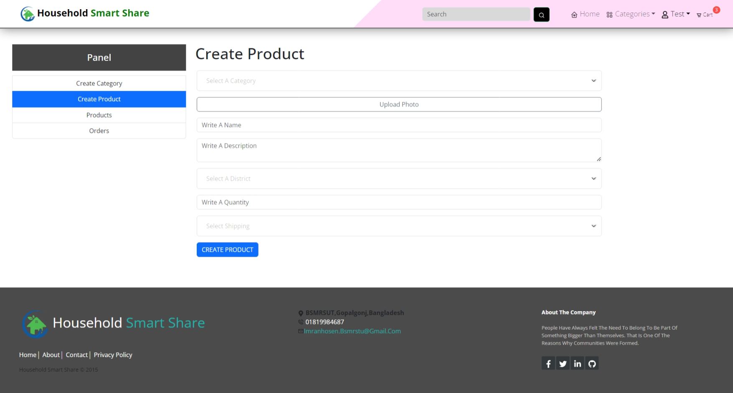In upload product we can upload our product. Below the image of Upload product shown in Figure-5.9.

Figure 11 Upload Product View

### **5.1.7 My upload:**

In upload option we can see which product we already uploaded. Below the picture of my upload view show in Figure-5.10.

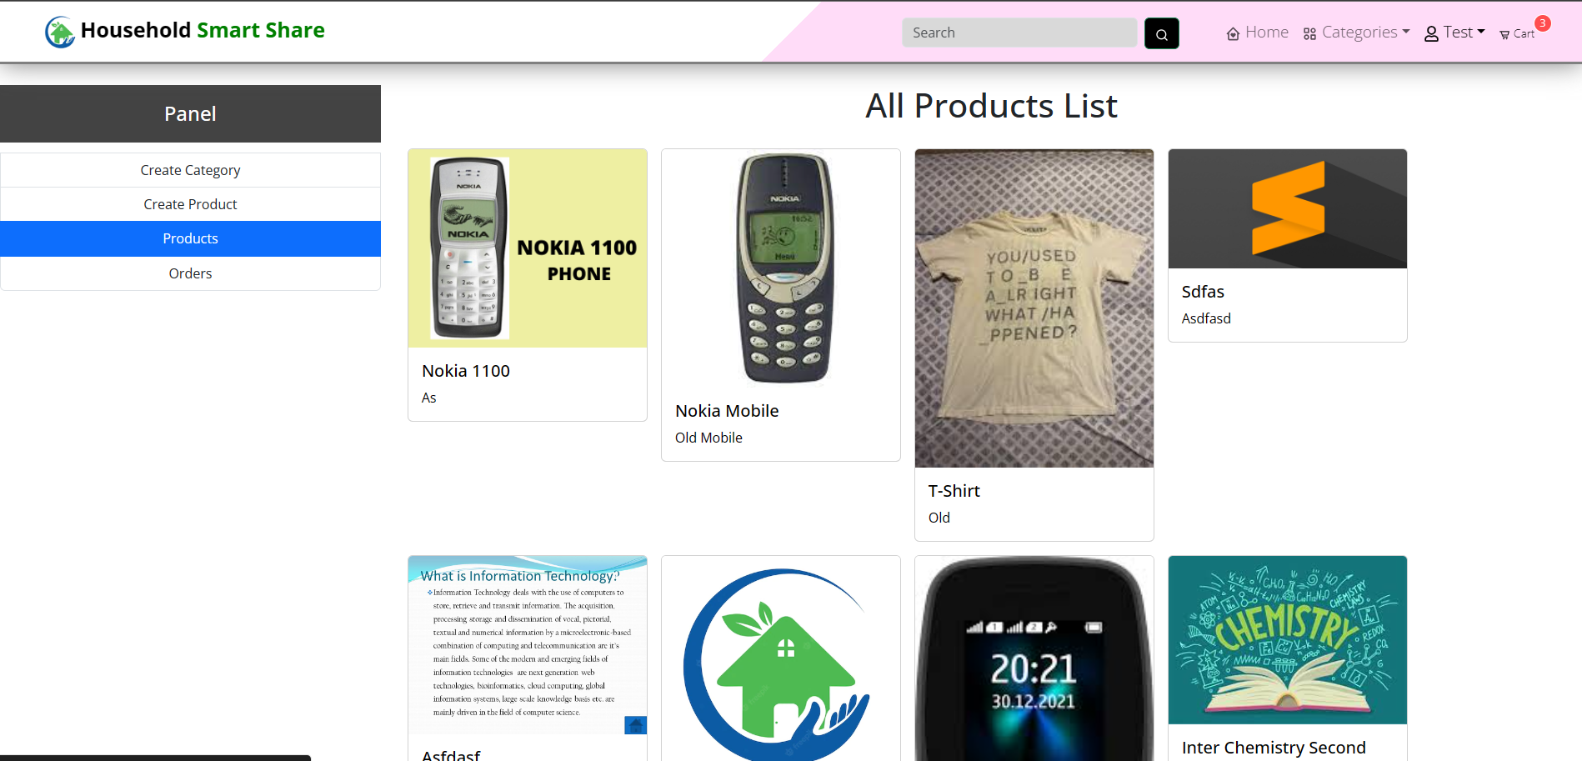

Figure 12 Own Upload Product View

### **5.1.8 My order:**

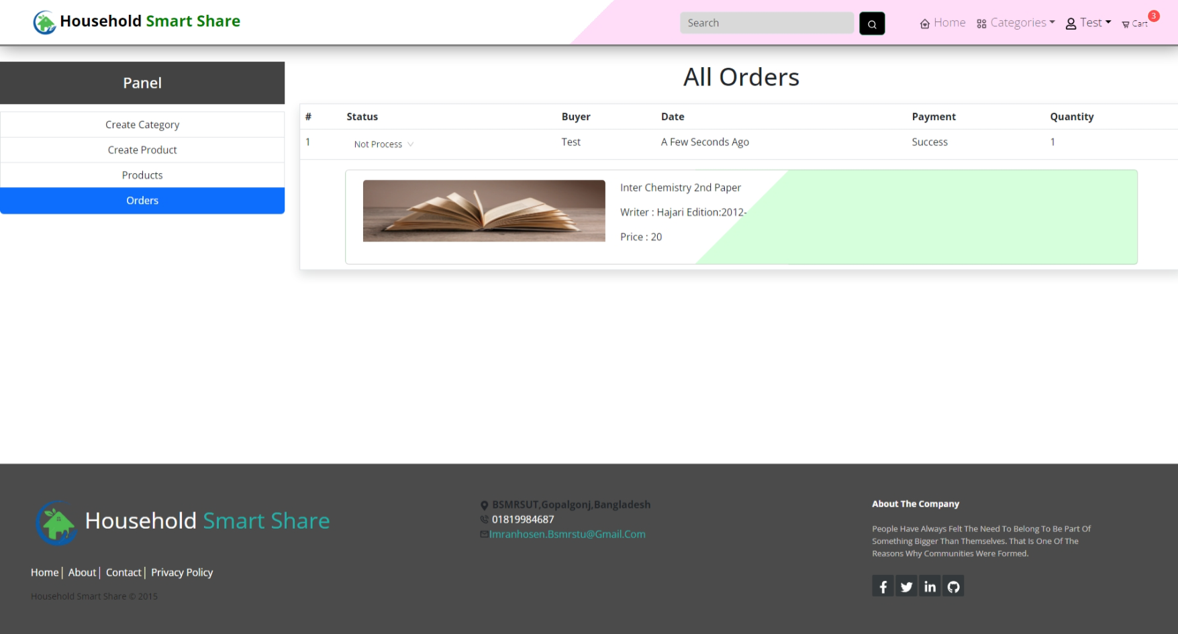In order fragment will which product we requested. Below the picture of my order view. We can also canc

Figure 13 My Order Request View

### **5.1.9 Cart Item:**

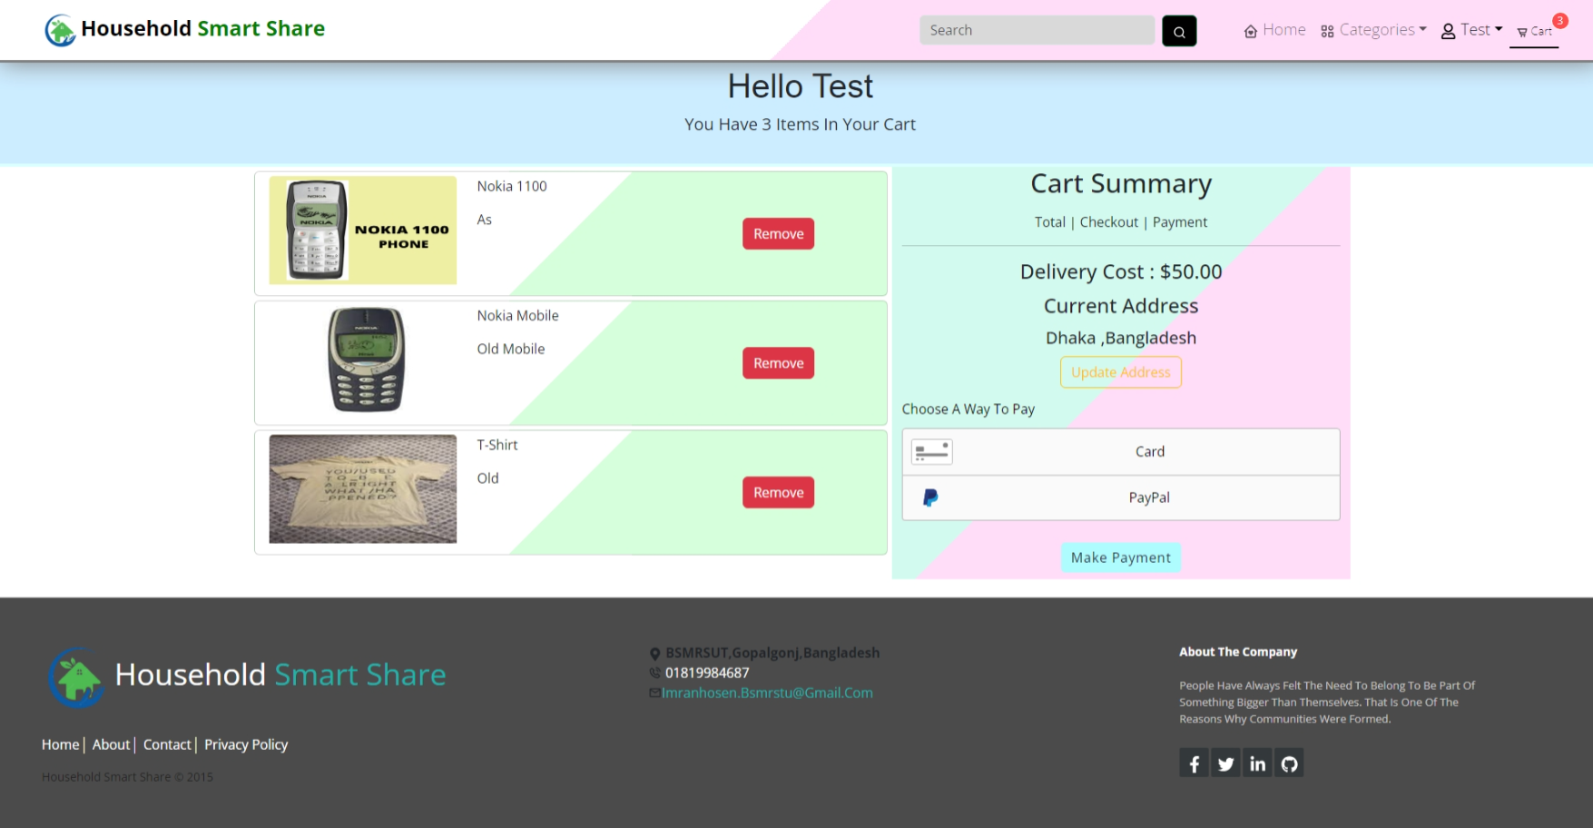In cart item all item show which we added to cart. Also we can remove item from cart using remove button and alson can request which shown in Figure-5.12.

Figure 14 Update Profile View

### **5.1.10 Filter Item:**

Using filter item we can filter or search our needed item easily. There are two filter add one is category other district which shown in below Figure 5.1.3.

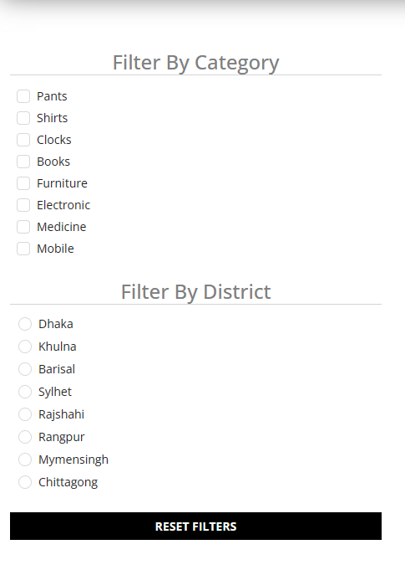

Figure 15 Filter Item

### **5.1.10 Item details view:**

In detail view we can show the details of a product like product descriptions and other things.Also we can see similar products below the detaile cart which shown in Figure 5.5.

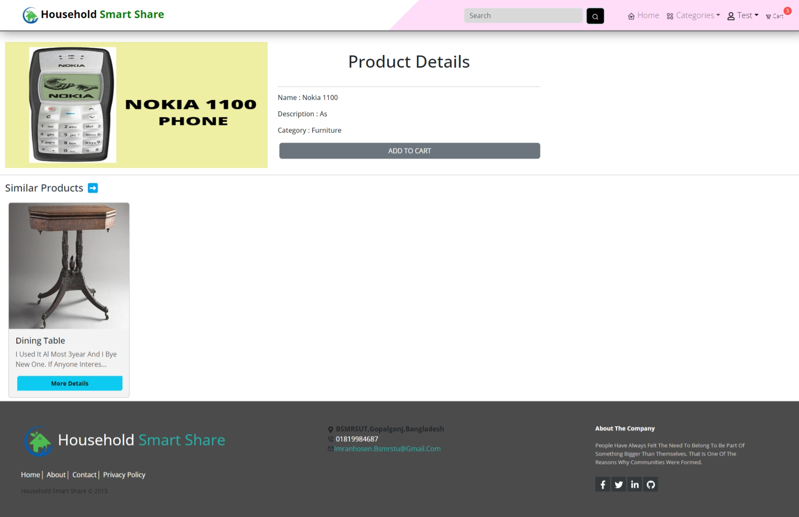

Figure 16 Item details view

# **Chapter 6**

# **Future Scopes**

There are several features of the project that would be quite challenging to be added. The desirable features that House Hold Smart Share could have.

* Including visual tour (location of items) inside the store to find items quickly using Google Map and Indoor Map API. It will help us in saving time and being tired too on searching for the items.
* Adding more feature for user flexibility.
* Increase more security.
* Online account verification and notification.
* Add chat system.

# **Chapter 7**

# **Conclusions**

We have learned a lot from this project on how to website and publishing it in real time, use Web Services using MongoDB, reporting using chart libraries, other libraries for scanning, payment, requirement gathering, css design, mongodb database, data formats. As mentioned, other existing websites does not help in avoiding people to stand in a long checkout line, instantly searching about availability of products, tracking purchases (all together in a single website). If people use House Hold Smart Share in the future, they have several advantages which includes, easy checkout, sharing invoices instantly as it is quite easy to misplace organizing them in easily, particularly helpful for elderly people by avoiding them to wait for a long time in the checkout line, providing quick information about items available, upload products which helps users to budget their expenses wisely and finally used and unused products.

# **References**

[1] https://en.wikipedia.org/wiki/Database_design

[2] [MongoDB: The Developer Data Platform | MongoDB](https://www.mongodb.com/)

[3] https://en.wikipedia.org/wiki/Relational_database

[4] https://ecomputernotes.com/database-system/rdbms/phases-of-design-methodology

[5] <https://en.wikipedia.org/wiki/Javascript> _(programming_language)

[6] [GeeksforGeeks | A computer science portal for geeks](https://www.geeksforgeeks.org/)

[7] <https://nodejs.org/en/docs>